**Global Food Production Trends and Analysis: A Comprehensive Study from 1961 to 2023 Using Power BI**

**Introduction:**

Global food production has undergone significant transformations from 1961 to 2023, driven by technological advancements, population growth, economic shifts, and climate change. Understanding these trends is crucial for ensuring food security, optimizing resource allocation, and developing sustainable agricultural practices.

This study, **"Global Food Production Trends and Analysis: A Comprehensive Study from 1961 to 2023 Using Power BI,"** aims to explore the patterns of food production worldwide, analyzing key crops, livestock, and fisheries data. By leveraging **Power BI**, an advanced data visualization and business intelligence tool, we will extract insights from historical datasets to identify production trends, regional disparities, and the impact of external factors such as climate change and economic policies.

Our research will focus on:

* **Growth and Distribution**: Analyzing how global food production has evolved over time and its regional variations.
* **Key Contributors**: Identifying the leading countries and commodities driving agricultural output.
* **Technology and Productivity**: Examining the impact of innovations such as the Green Revolution, irrigation expansion, and mechanization.
* **Environmental and Economic Influences**: Assessing the role of climate change, trade policies, and economic growth on food production.

Through interactive Power BI dashboards, this study will present data-driven insights, allowing policymakers, researchers, and stakeholders to make informed decisions about global food security and sustainability.

**Technical Architecture:**

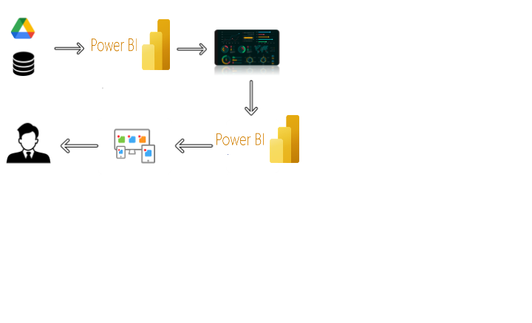

**Project Flow:**

To accomplish this, we have to complete all the activities listed below,

* Data Collection & Extraction from Database
  + Collect the dataset,
  + Storing Data in DB
  + Perform SQL Operations
  + Connect DB with Power Bi
* Data Preparation
* Prepare the Data for Visualization
* Data Visualizations
  + No of Unique Visualizations
* Dashboard
  + Responsive and Design of Dashboard
* Report
  + Responsive and Design of Dashboard
* Performance Testing
  + No of Visualizations/ Graphs
* Project Demonstration & Documentation
  + Record explanation Video for project end to end solution
  + Project Documentation-Step by step project development procedure

**Milestone 1: Data Collection & Extraction from Database**

Data collection is the process of gathering and measuring information on variables of interest, in an established systematic fashion that enables one to answer stated research questions, test hypotheses, and evaluate outcomes and generate insights from the data.

**Activity 1: Collect the dataset**

Please use the link to download the dataset: [Link](https://www.kaggle.com/datasets/rafsunahmad/world-food-production)

Activity 1.1: Understand the data

Data contains all the meta information regarding the columns described in the CSV files

Column Description of the Dataset:

* Entity: Represents the country or region where the food production data is recorded.
* Code: A unique identifier or code for each entity (country or region).
* Year: The specific year for which the data is recorded, ranging from 1961 to 2023.
* Apples_Production (tonnes): The total annual production of apples measured in tonnes.
* Avocados_Production (tonnes): The total annual production of avocados measured in tonnes.
* Bananas_Production (tonnes): The total annual production of bananas measured in tonnes.
* Coffee_green_Production (tonnes): The total annual production of green coffee measured in tonnes.
* Grapes_Production (tonnes): The total annual production of grapes measured in tonnes.
* Maize_Production (tonnes): The total annual production of maize measured in tonnes.
* Oranges_Production (tonnes): The total annual production of oranges measured in tonnes.
* Rice_Production (tonnes): The total annual production of rice measured in tonnes.
* Tea_Production (tonnes): The total annual production of tea measured in tonnes.
* Wheat_Production (tonnes): The total annual production of wheat measured in tonnes.

**Activity 2: Connect Data with Power BI**

* With Power BI, users can seamlessly connect to a wide range of data sources, including databases, cloud services, spreadsheets, and streaming data. This capability allows organizations to consolidate disparate data sources into a single, unified platform, breaking down data silos and enabling holistic analysis.
* Explanation video link:

**Milestone 2: Data Preparation**

* Data preparation is a critical phase in the data lifecycle, encompassing activities that transform raw data into a format suitable for analysis. This multifaceted process involves several steps including data cleaning, integration, transformation, and enrichment. Data cleaning involves identifying and rectifying errors, inconsistencies, and missing values within datasets to ensure accuracy and reliability.

**Activity 1: Prepare the Data for Visualization**

* Preparing the data for visualization involves cleaning the data to remove irrelevant or missing data, transforming the data into a format that can be easily visualized, exploring the data to identify patterns and trends, filtering the data to focus on specific subsets of data, preparing the data for visualization software, and ensuring the data is accurate and complete. This process helps to make the data easily understandable and ready for creating visualizations to gain insights into the performance and efficiency.

### Milestone 3: Data Visualization

Data visualization is the process of creating graphical representations of data to help people understand and explore the information. The goal of data visualization is to make complex data sets more accessible, intuitive, and easier to interpret. By using visual elements such as charts, graphs, and maps, data visualizations can help people quickly identify patterns, trends, and outliers in the data.

**World Food Production(1961-2023)**

 Activity 1.1: Sum of Rice Production (tonnes)

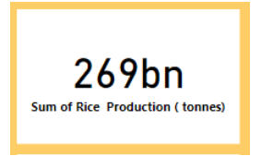

   Activity 1.2: Sum of Wheat Production (tonnes)

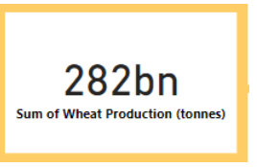

 Activity 1.3: Sum of Tea Production (tonnes)

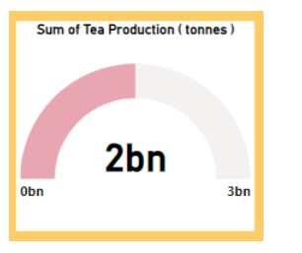

 Activity 1.4: Sum of Coffee, Green Production (tonnes) by Entity

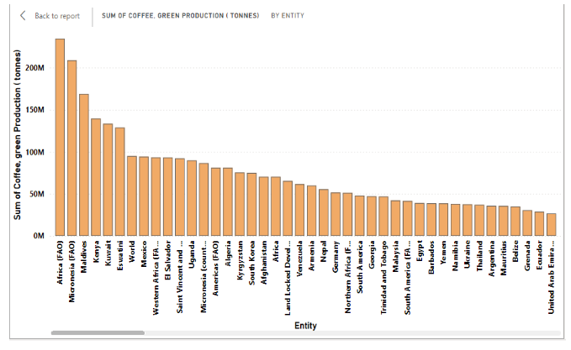

   Activity 1.5:  Sum of Wheat, Maize, and Rice Production (tonnes) by Year

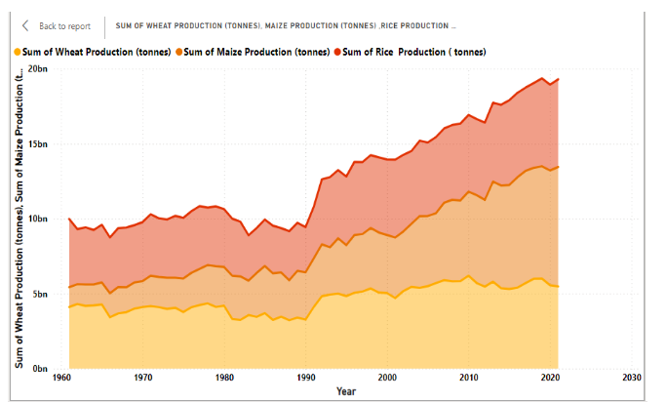

Activity 1.6: Sum of Apples, Avocados, Bananas, and Oranges Production          (tonnes) by Entity

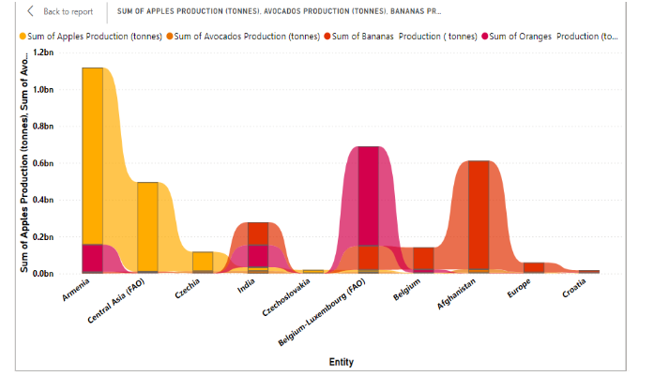

Activity 1.7: Sum of Maize Production (tonnes) by Year

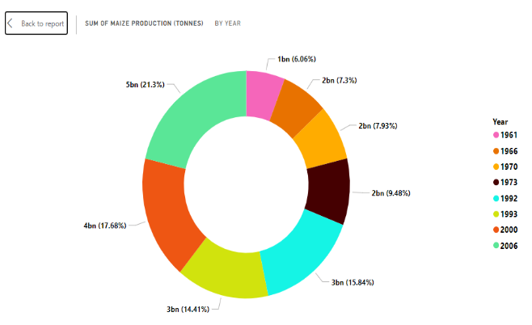

Activity 1.8: Sum of Grapes, Apples, Bananas, and Oranges Production (tonnes)

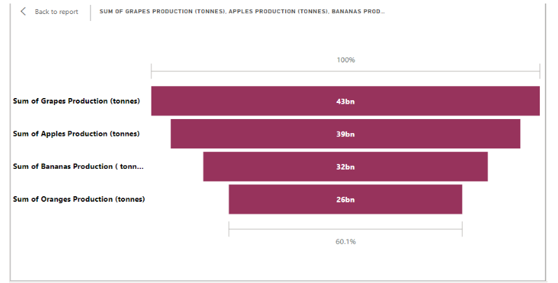

**Milestone 4: Dashboard**

A dashboard is a graphical user interface (GUI) that displays information and data in an organized, easy-to-read format. Dashboards are often used to provide real-time monitoring and analysis of data, and are typically designed for a specific purpose or use case. Dashboards can be used in a variety of settings, such as business, finance, manufacturing, healthcare, and many other industries. They can be used to track key performance indicators (KPIs), monitor performance metrics, and display data in the form of charts, graphs, and tables.

**Activity :1- Responsive and Design of Dashboard**

The responsiveness and design of a dashboard for Social Pulse Illuminating the Digital Footprint  Unveiling Social Media Engagement Is crucial to ensure that the information is easily understandable and actionable. Key considerations for designing a responsive and effective dashboard include user-centred design, clear and concise information, interactivity, data-driven approach, accessibility, customization, and security. The goal is to create a dashboard that is user-friendly, interactive, and data-driven, providing actionable insights to improve the performance and efficiency of Social Pulse Illuminating the Digital Footprint  Unveiling Social Media Engagement.

Once you have created views on different sheets in Power Bi you can pull them into a dashboard.

Dashboard 1 :

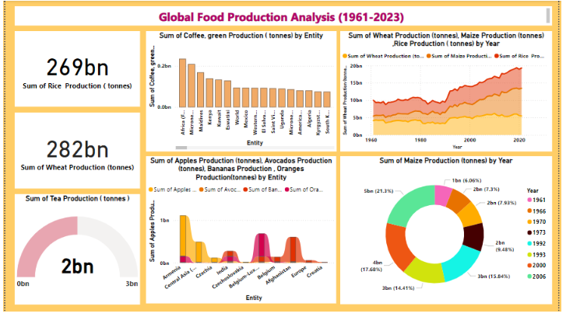

**Milestone 5: Report**

A data report is a way of presenting data and analysis in a narrative format, with the goal of making the information more engaging and easier to understand. A data story typically includes a clear introduction that sets the stage and explains the context for the data, a body that presents the data and analysis in a logical and systematic way, and a conclusion that summarizes the key findings and highlights their implications. Data Report can be told using a variety of mediums, presentations, interactive visualizations, and videos.

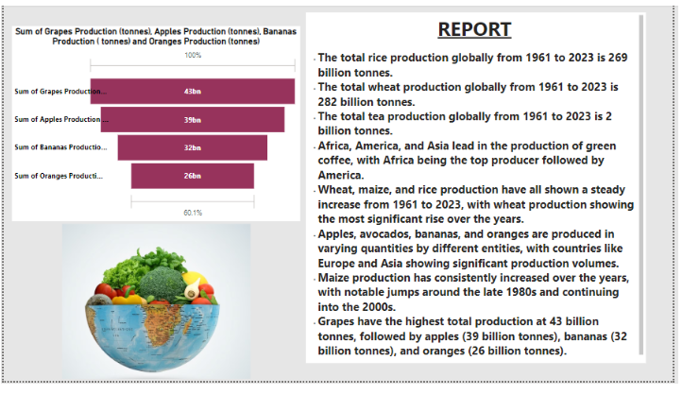

### Milestone 6: Performance Testing

### Amount of Data Loaded

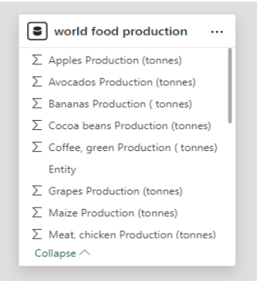

"Amount of Data Loaded" refers to the quantity or volume of data that has been imported, retrieved, or loaded into a system, software application, database, or any other data storage or processing environment. It's a measure of how much data has been successfully processed and made available for analysis, manipulation, or use within the system.

**Utilization of Filters:**

"Utilization of Filters" refers to the application or use of filters within a system, software application, or data processing pipeline to selectively extract, manipulate, or analyze data based on specified criteria or conditions.

Activity 2.1: Selected “Country” as a Filter

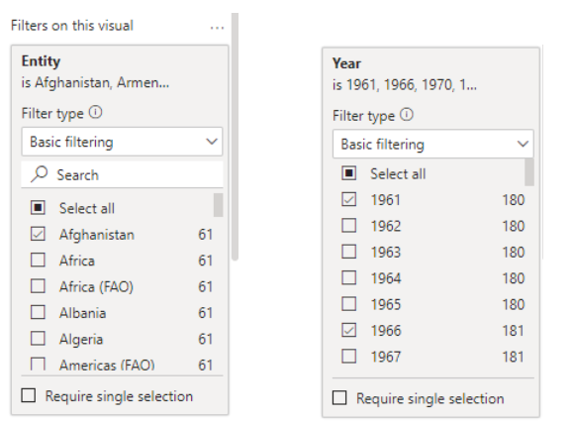

Activity 2.2: No of Visualizations/ Graphs

* Sum of Rice Production (tonnes)
* Sum of Wheat Production (tonnes)
* Sum of Tea Production (tonnes)
* Sum of Coffee, Green Production (tonnes) by Entity
* Sum of Wheat Production (tonnes), Maize Production (tonnes), Rice Production (tonnes) by Year
* Sum of Apples, Avocados, Bananas, Oranges Production (tonnes) by Entity
* Sum of Maize Production (tonnes) by Year
* Sum of Grapes, Apples, Bananas, Oranges Production (tonnes)

### Milestone 7: Project Demonstration & Documentation

Activity 1: - Record explanation Video for the project's end-to-end solution

Link: <https://drive.google.com/file/d/1c_vzTXanf9gsIwGTxR5KdDUd68lj7cWj/view?usp=sharing>

Activity 2: - Project Documentation-Step by step project development procedure

Link: <https://docs.google.com/document/d/1Ez0XE8JbM-QH2OFtsP6sbrKkzpVxoiF_/edit?usp=sharing&ouid=101435304570746346801&rtpof=true&sd=true>